STEPHENSON AWARD
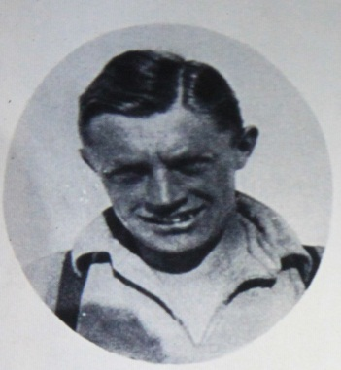
The Stephenson Award is given annually to an individual who is a member of the Young Explorers’ Trust or an affiliated expedition group for outstanding service to youth expeditioning.

The Award is named after Alfred Stephenson who was the first Chairman of the YET Expedition Screening Panel and a great believer in the value of youth expeditions. He was a noted polar explorer and a member of the highly successful British Graham Land Expedition 1935 -1937 now called the Antarctic Peninsula. He was also secretary of the Antarctic Club for over 40 years.

Nominees can be of any age, and there are many ways by which such service may occur. For example, for a:

- long period of involvement with the youth expedition scene
- young member who has later developed active leadership skills
- young member who has made a particular contribution to an expedition in the field.

Previous winners include
Mark Smith – expedition leadership with YSES, service to youth
exploration through environmental publications
Maggie Brown – convener of the YET Youth Exploration Awards
Philly Jones - member and assistant leader of Liverpool Schools’ Sahara Expeditions
Brian Ware – Services to Brathay and YET

Nominations submitted by 1st June will be considered by a Panel and the Award Winner announced in mid-June. Please return them by email to tedgrey91@gmail.com

STEPHENSON AWARD NOMINATION (please print)

A. Person nominated ………………………………………………………

Address ……………………………………………………………………………………….………

…………………………………………………………………………………………………

Tel ……………………………..Age (approx) ………E-mail ……………………………………

B. I wish to nominate the above person:

Name ………………………….. ………….. ..Signed ……………………………………….

Address ……………………………………………………………………………………………
………………………………………………………………………………………

Tel ……………………………………E-mail……………………………………………………
Cont. on Page 2

C. Please give your reasons below in support of your nomination with particular reference to the above criteria of outstanding service, and saying whether it is for long service or a special one-off achievement. Please write 200-300 words giving the Panel as much information as possible to aid its decision.

